EW-1 LAB-4

Snigdha Stp

2023102036

Table number: 11

Name of the Experiment :

Voltage regulator-Zener diode.

Aim:

1. Designing a simple voltage regulator circuit using a zener diode.

2. Bringing out the contrast between the performance of this circuit and an IC voltage regulator.

3. Checking the noise performance of the circuit

A simple voltage circuit is shown below:

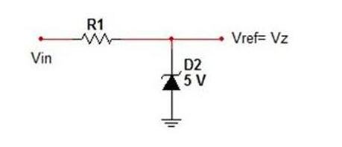

A Zener diode is used as a voltage regulator when operated in reverse bias.

A resistor is connected to it in series to maintain the diode current and a load in parallel to maintain the same voltage irrespective of the value of the load.

One problem with Zener diode stabilising circuit is that it generates electrical noise as it tries to stabilise voltage, so, a large value of decoupling capacitance is connected across the zener’s output for additional smoothing. For this, instead of a regulator circuit, we chose to build an IC7805 circuit.

Lab exercise:

1. Connect a DC input of 15V, a resistor of 1kΩ and a zener diode rated at 5V . Connect a load resistor RL across the diode. Draw this circuit in LTSpice & run transient simulation.

2. Insert a DC input of 15V to the regulator circuit and measure the output voltage across RL. Vary RL from 100Ω to 5K and note how the output voltage is changing (.op).

3. Now connect the voltage regulator circuit at the load of rectifier circuit with smoothing filter (C=2200uF) and repeat the study of the previous step.(transient)

4. Now instead of the zener circuit shown in the above figure we will consider the Spice model of an IC7805 circuit and connect it to the input DC excitation and output load RL.

5. Repeat the tests from step. 2 and step. 3.

6. Turn off source excitation and perform a noise analysis on the circuit at the output up to 10KHz.

7. Introduce a smoothing capacitor at the output of the IC7805 in parallel to the load. Change the capacitor from 5uF to 500uF and observe the noise performance of the resulting circuit.

RESULT:

LTSpice simulations

1. A transient simulation for RL value= 10k ohms:

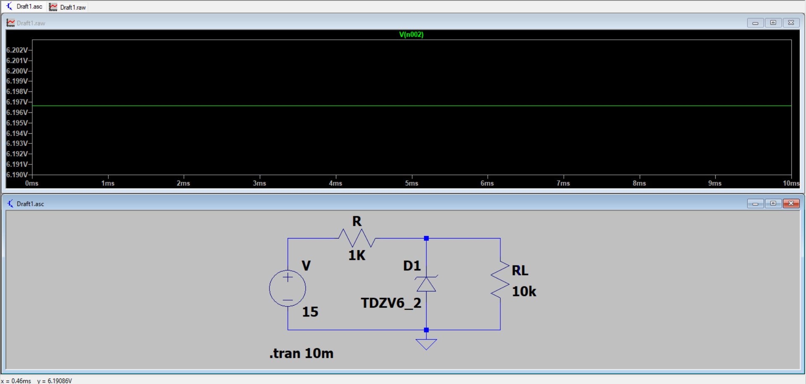

1. Varying RL from 100k ohms to 5k ohms

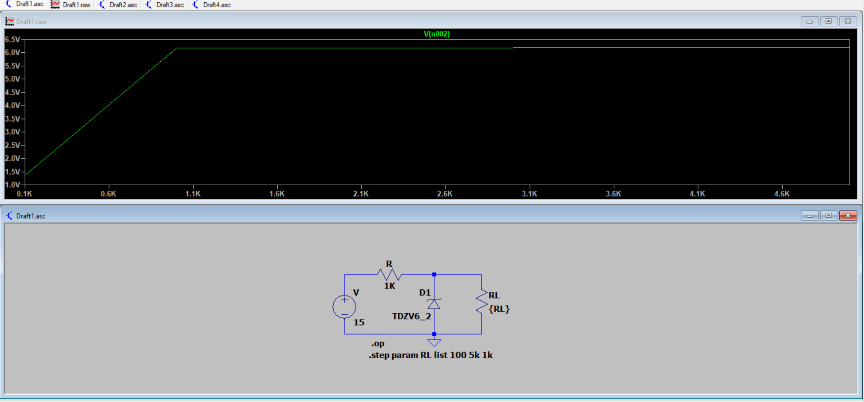

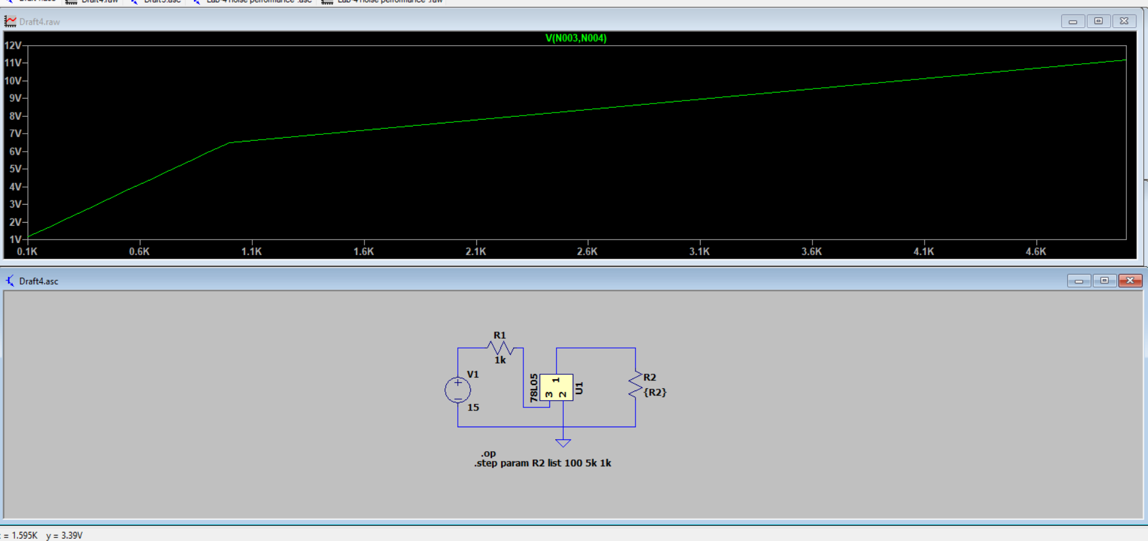

1. Connecting the voltage regulator circuit with a capacitance of 2200uF.

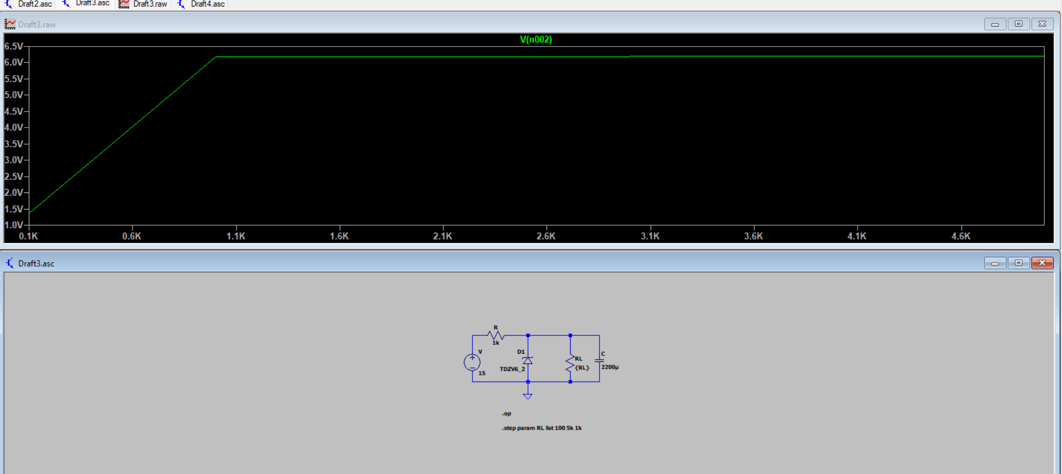

1. With an IC7805

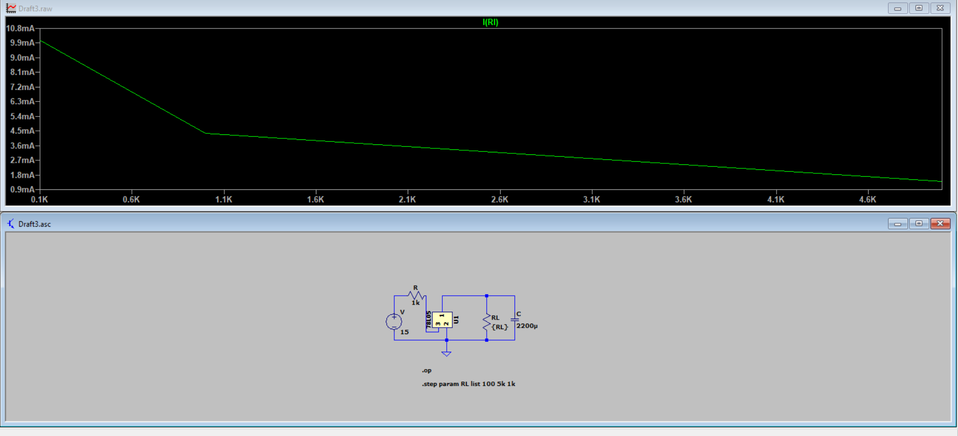

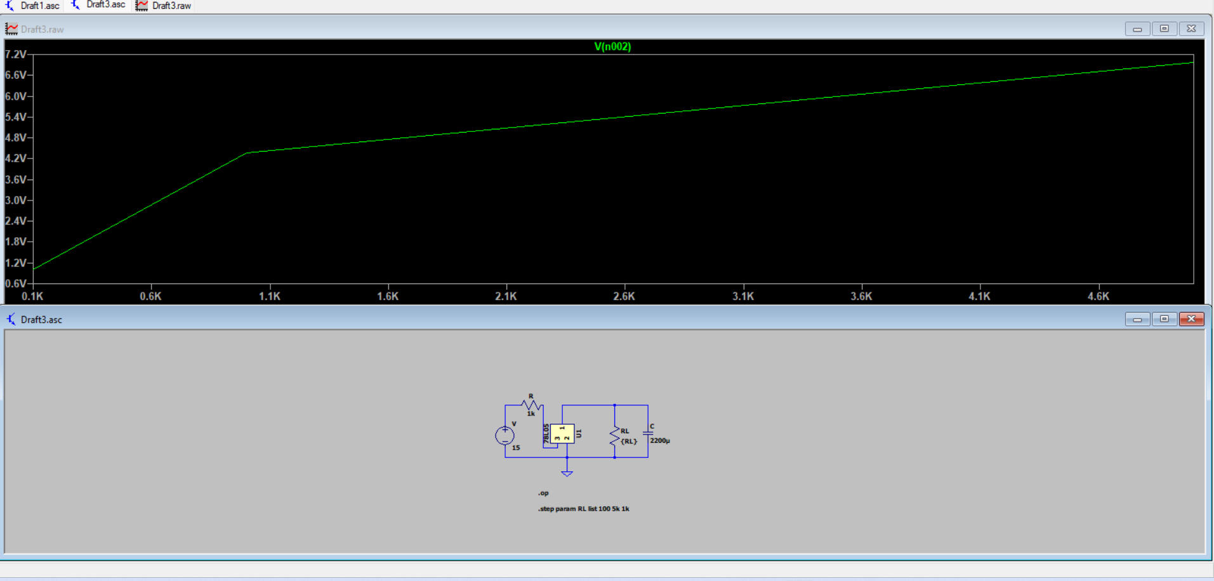

1. Performing noise analysis on the circuit:

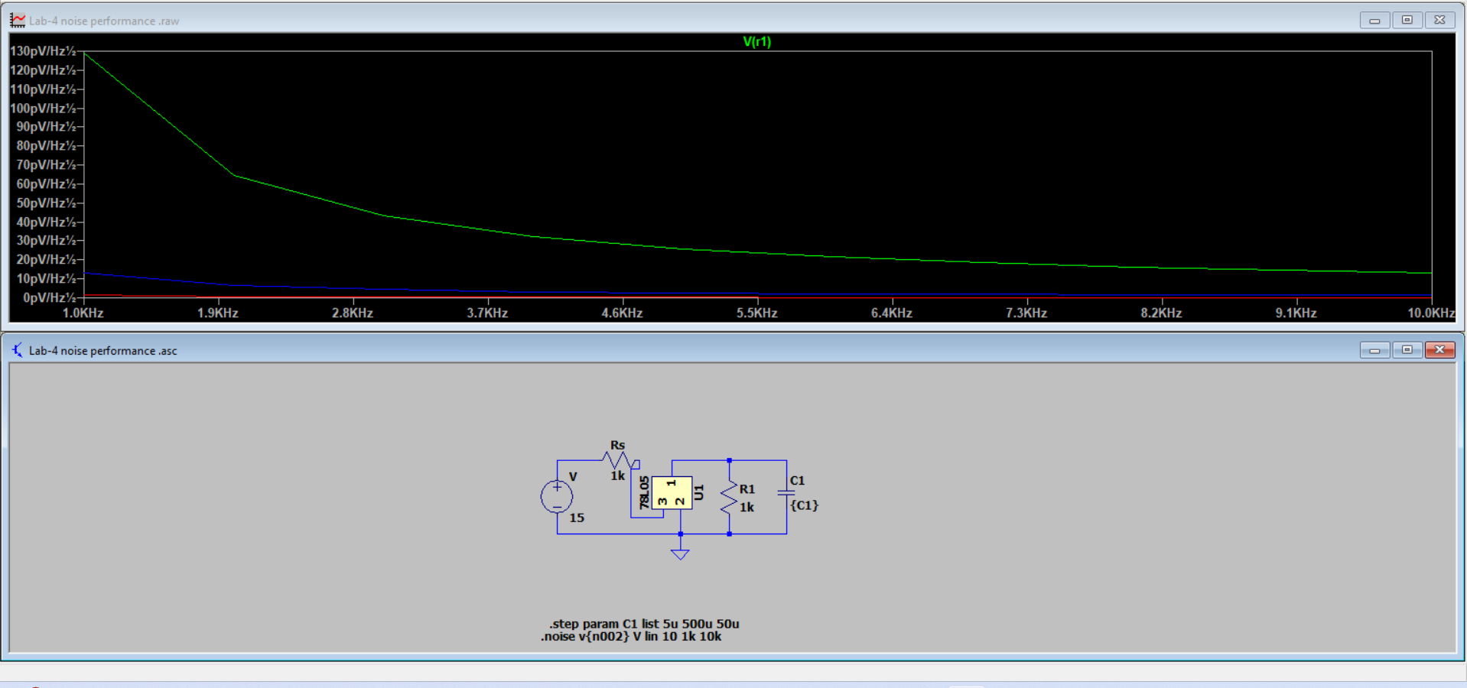

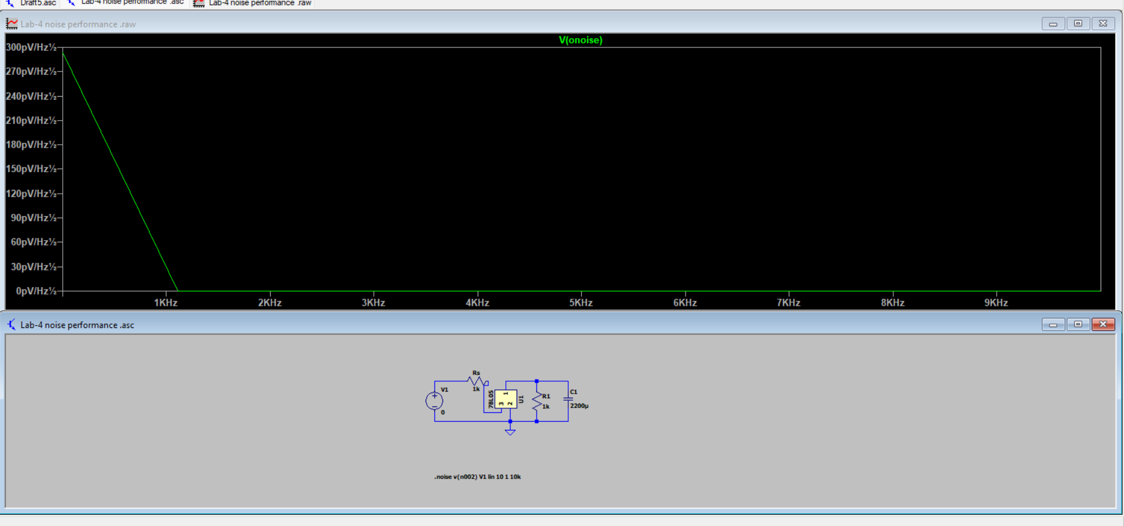

Observations :

Keeping Rz(value=330 ohms) constant:

1. When RL = 10K

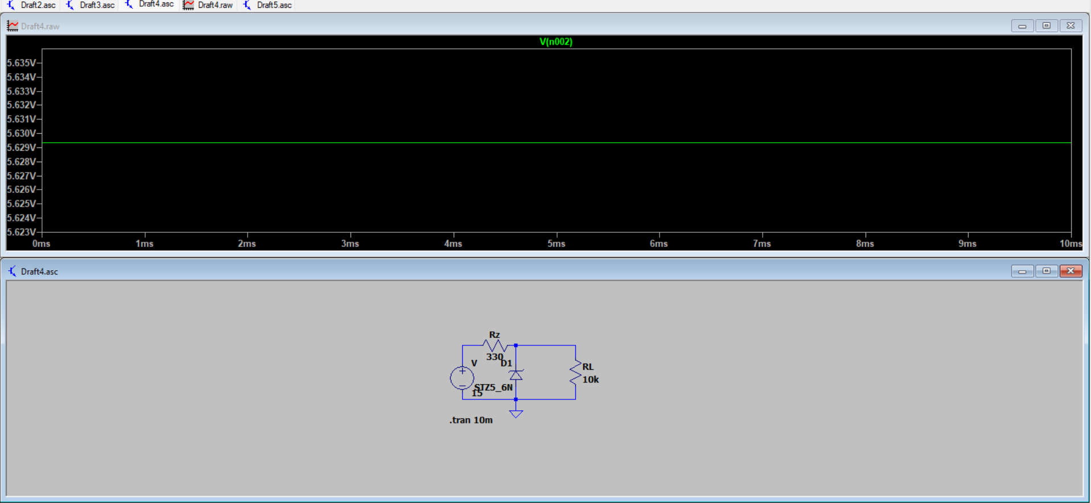

1. When RL=3.3k

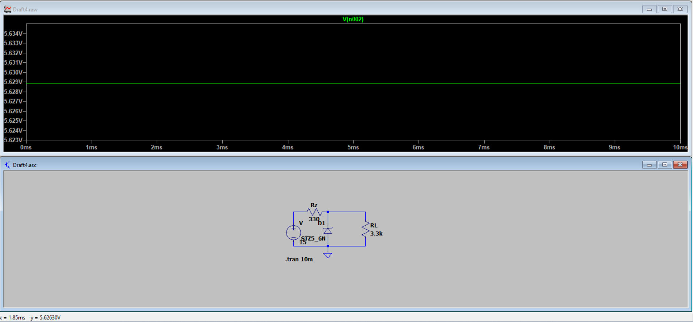

1. When RL=390

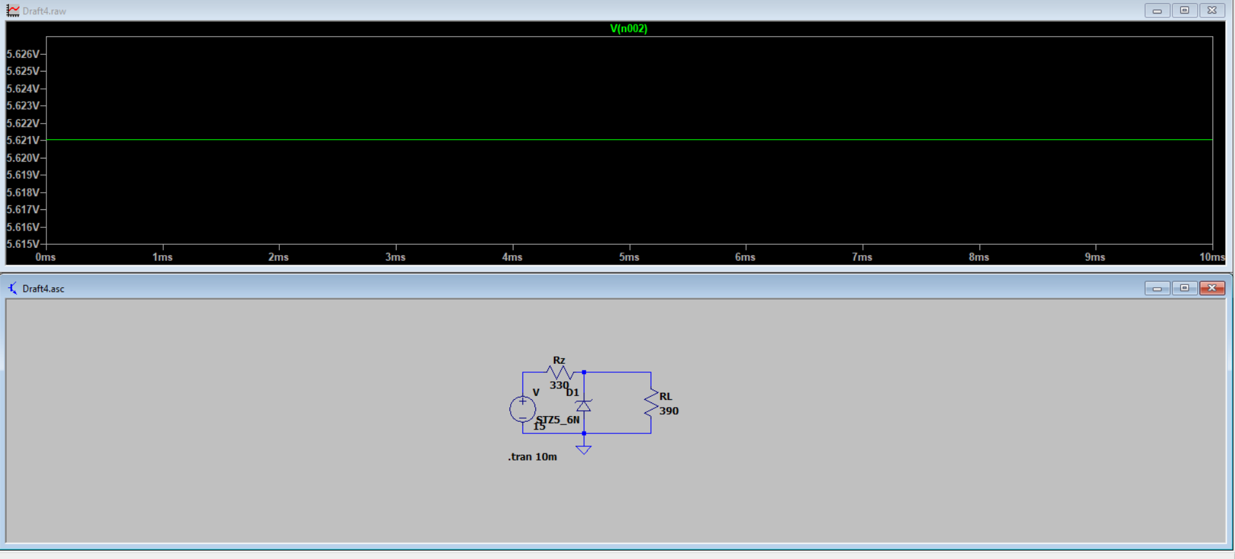

4.When RL= 100 ohms

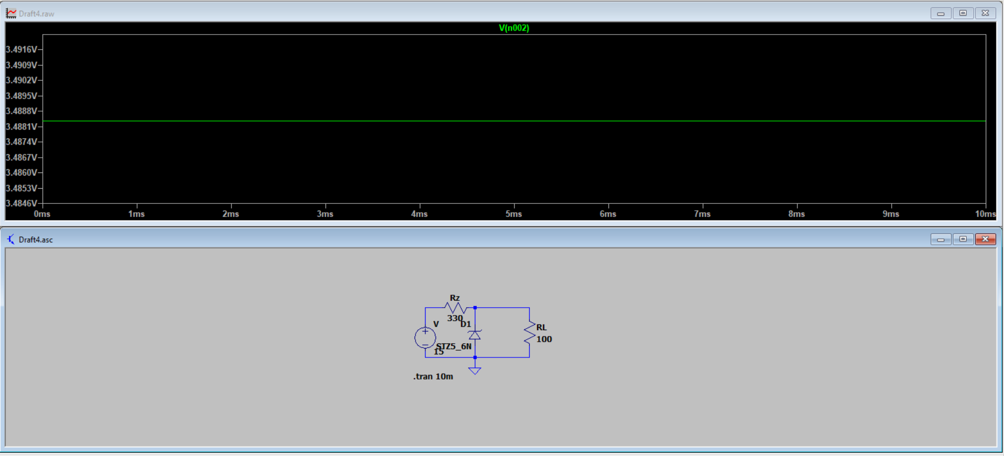

Keeping RL constant:

1. When Rz= 1k ohms

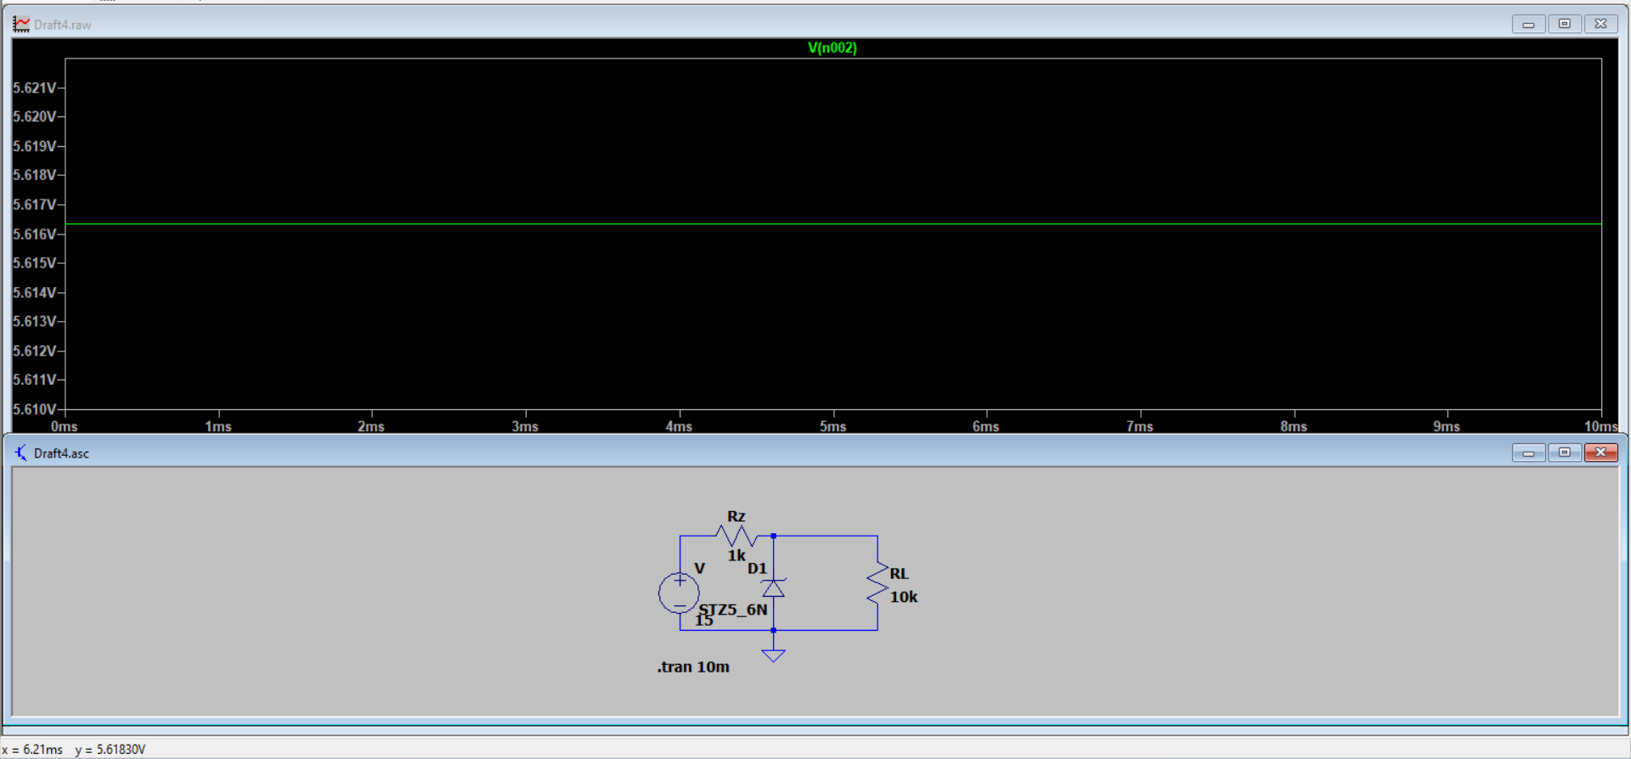

1. When Rz=3.3k ohms

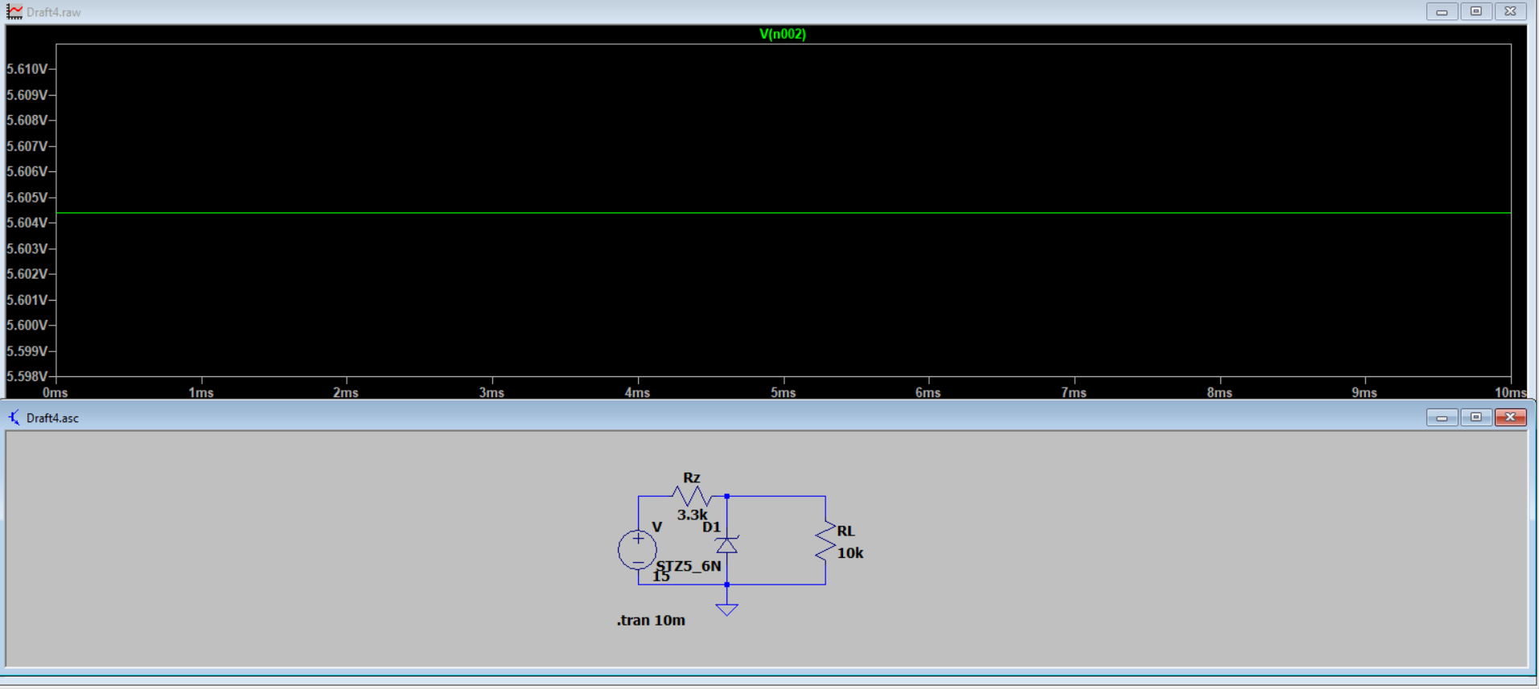

1. When Rz= 330 ohms

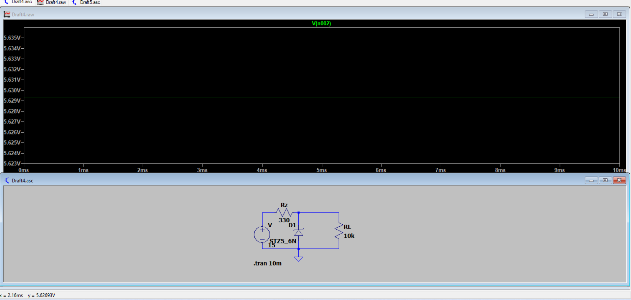

1. When Rz=390 ohms

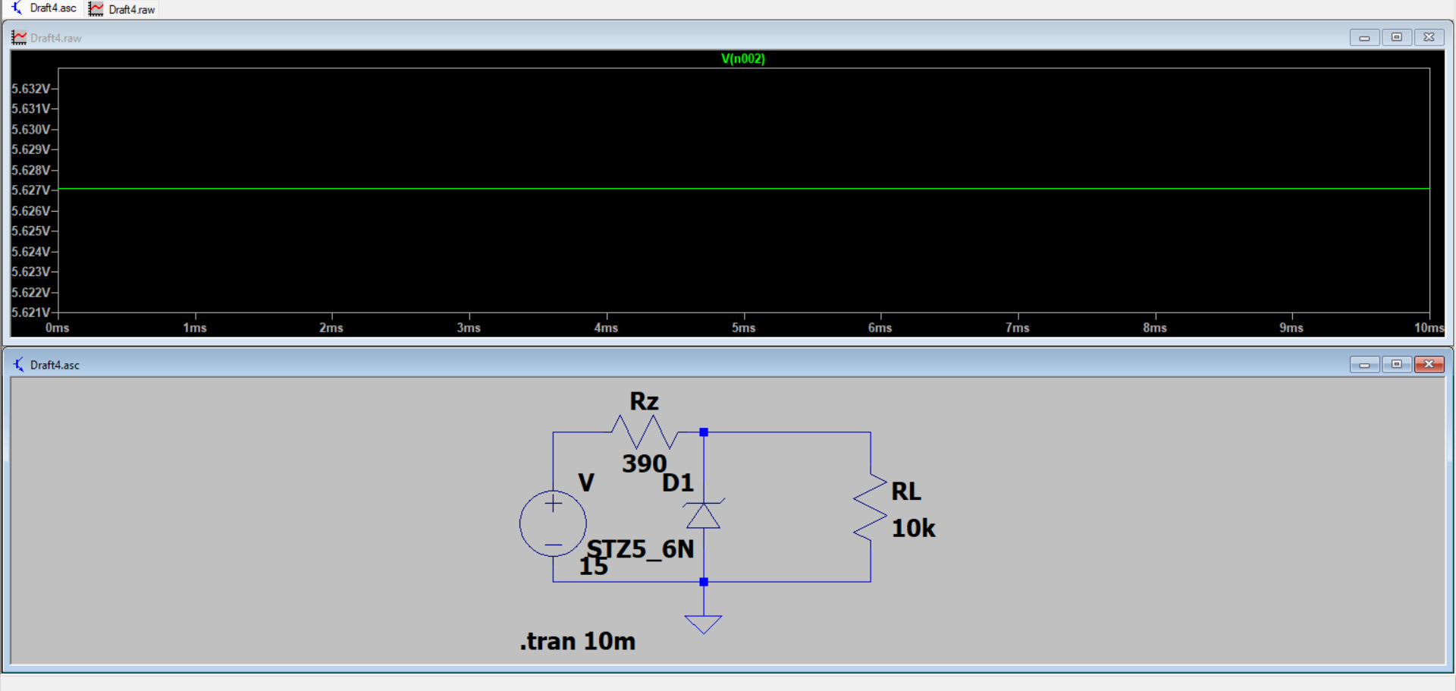

Previous observation table:

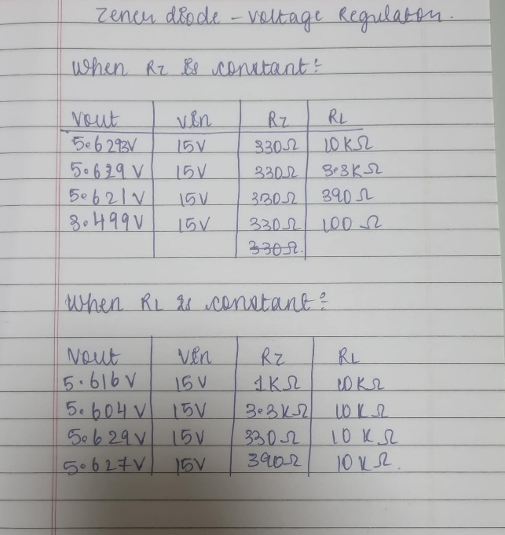

As we change the load, the current through the Zener diode changes. When the load becomes small, most of the current will flow through the load, thus the zener range will decrease. At that point, the output voltage V out will drop below Vz.

Conclusion:

We can see from above, that the output voltage remains constant and the IC7805 circuit can be used as an alternative to the Zener circuit. We can also conclude that, with the help of a capacitance in the circuit the noise generated can get smoothened.